**Munzer Mahmood Project Documented Design Section**

**Design of MediApp:**

I undertook several investigations to see how I could improve the current system to the best of its ability.

Data Flow Diagram For New System

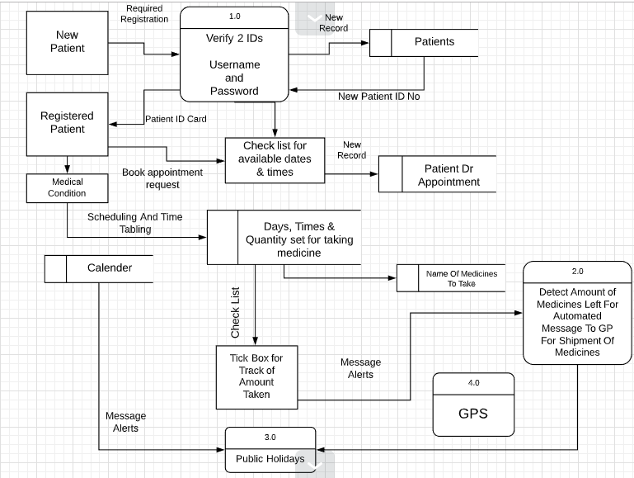

**Modelling The New System:**

**IPSO Analysis Chart**

|  |  |  |
| --- | --- | --- |
| **IPSO** | **Information** | **Evidence** |
| Input | Customer Information:   * First name - Email * Surname - Address * Phone Number - Medical History * DOB -Bank Details | Observation notes/Interview |
| Input | Medicine Scheduling Information:   * Date and Time -Medical Condition * Dosage -GP Information * Prescription Details | Observation notes |
| Process | * Remind patient to take medicine * Shipment of medicine by use of data from patient details * Find Location using GPS * Automated messages * Banking Transactions * Calculating the cost of orders | Observation notes |
| Store | -Patient Details  -Medicine Scheduling Details  -Prescription Details | Observation notes |
| Output | - Medication reminders  -Instruction of based output from user  -Automatic Orders | Observation notes/Interview |

**Entity Attribute Model**

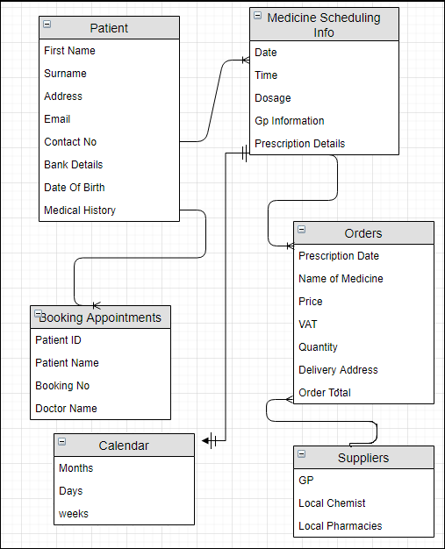

**tblPatient( PatID, PatFirstName, PatSurname, PatUsername, PatPassword, PatAddress, PatPostcode, PatEmail, PatBankingDetails, PatPhoneNo, PatDOB**

**PatMedicalCondition)**

**tblOrders(OrderID, SupplierID#1(FK), PatientID#2(FK)PrescriptionDate, NameofMedicine, Price, VAT, Quantity, DeliveryAddress, OrderTotal)**

**tblBookingAppointsments(BookingID,PatientID(FK), PatientFirstName, PatientSurname DoctorName, Time, Date, Reason)**

**tblCalendar(Months, Weeks, Days)**

**tblsuppliers(LocalChemist, LocalPharmacies, GP)**

**tblMedicineSchedulingInfo(Date, Time, Dosage, PrescriptionDetails)**

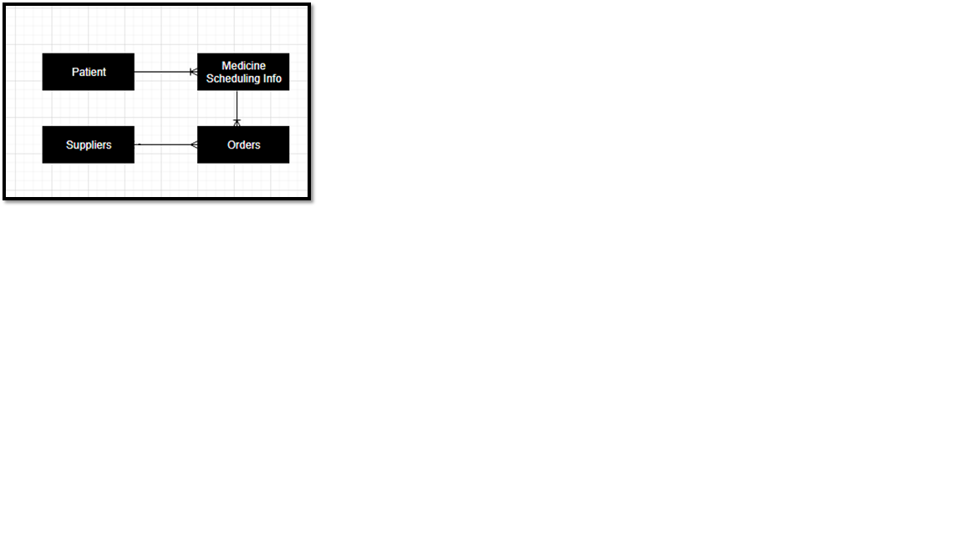**Pre-Normalization ERD**

**Post-Normalization ERD**

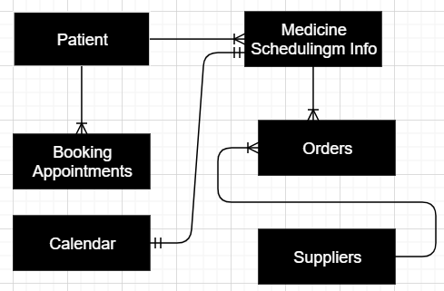

**DATA DICTIONARIES**

|  |  |
| --- | --- |
| Table Name | Patients |
| Primary Key | Patient ID |
| Foreign Key | N/A |

|  |  |  |  |
| --- | --- | --- | --- |
| Data Item | Data type | Validation | Sample Data |
| Patient ID | Integer | Length of 6, Integer | 112439 |
| Patient FirstName | String | NotNull | Jason |
| Patient Surname | String | NotNull | Aberfield |
| Patient Username | String | Length of 8, String | J.Aberfield |
| Patient Password | String | >8 characters | Jason1232 |
| Patient Address | String | NotNull | 39 Romford Road,London |
| Patient Postcode | String | NotNull | E7 9HL |
| Patient Email | String | NotNul, Must have ‘@’ | j.aberfield@gmail.com |
| Patient Banking Details | String | NotNull | Sort Code: 40-05-66  Account Number: 2335 7777 9856 4312  CVV: 487 |
| Patient Phone No | String | = 11 digits | 07508824572 |
| Patient DOB | Date And Time | DD/MM/YY | 23/08/1997 |
| Patient Medical Condition | String | NotNull | Schizophrenia |

|  |  |
| --- | --- |
| Table Name | Booking Appointments |
| Primary Key | Booking ID |
| Foreign Key | Patient ID |

|  |  |  |  |
| --- | --- | --- | --- |
| Data Item | Data Type | Validation | Sample Data |
| Booking ID | Integer | Length of 6, Integer | 178902 |
| Patient ID | Integer | Length of 6, Integer | 112439 |
| Patient FirstName | String | NotNull | Jason |
| Patient Surname | String | NotNull | Aberfield |
| Date | Date And Time | DD/MM/YY & >=CurrentDate | 14/06/2020 |
| Time | Date And Time | HH/MM/SS & >=CurrentDate | 03:45 pm |
| Doctor Name | String | NotNull | Dr Arnold |

|  |  |
| --- | --- |
| Table Name | Orders |
| Primary Key | Order ID |
| Foreign Key | Supplier ID |

|  |  |  |  |
| --- | --- | --- | --- |
| Data Item | Data Type | Validation | Sample Data |
| Order ID | Integer | Length of 6, Integer | 578940 |
| Supplier ID | Integer | Length of 6, Integer | 332976 |
| NameOfMedicine | String | NotNull | Alatrol |
| PrescriptionDate | Date And Time | DD/MM/YY & >=CurrentDate | 12/09/2020 |
| Price | Real | Printed by 2 d.p in GBP | £12.99 |
| VAT | Real | Printed by 2 d.p in GBP | £3.25 |
| Quantity | Integer | NotNull & in Integer | 9 |
| Delivery Address | String | NotNull | 39 Romford Road, London |
| Delivery PostCode | String | NotNull | E7 9HL |
| Order Total | Real | Printed by 2 d.p in GBP | £16.24 |

|  |  |
| --- | --- |
| Table Name | Medicine Scheduling Info (for Medication Reminders) |
| Primary Key | N/A |
| Foreign Key | N/A |

|  |  |  |  |
| --- | --- | --- | --- |
| Data Item | Data Type | Validation | Sample Data |
| Date | Date & Time | DD/MM/YY & >=CurrentDate | 12/02/2020 |
| Time | Date & Time | HH/MM/SS & >=CurrentDate | 02:30pm |
| Dosage | Integer | >0 | 7 Medicines including Paracetamol,Alatrol,etc |
| Prescription Details | String | LongText | “Name  Address  Dexcom G5 Receiver Dispense 1/0 Refills  Dexcom G5 Transmitter Dispense 1/3 Refills  **Use As Directed”**  Signature: |

|  |  |
| --- | --- |
| Table Name | Suppliers |
| Primary Key | Supplier ID |
| Foreign Key | Order ID |

|  |  |  |  |
| --- | --- | --- | --- |
| Data Item | Data Type | Validation | Sample Data |
| Supplier ID | Integer | Length of 6, Integer | 897652 |
| SupplierCompanyName | String | NotNull | AbdulPharmacies |
| OrderID | Integer | Length of 6, Integer | 387790 |
| OrderFrequency | Integer | >=1 | 25 paracetamol packages, 12 strips of Alatrol etc |

**Context Diagram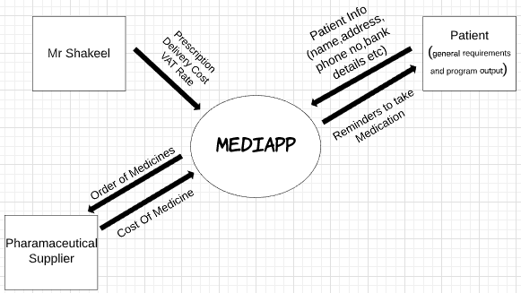 For New System**

**Nearest pharmacies**

**GPS**

**Location**

**feedback**

GP

Prescription changing updates

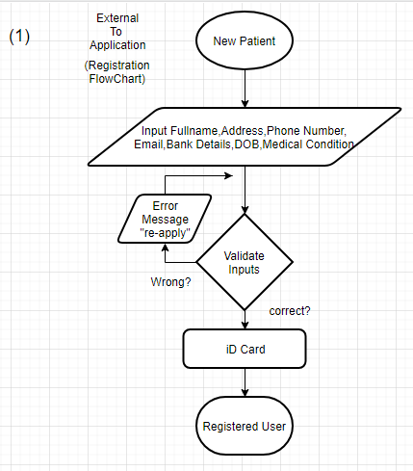 **Flow Chart Diagrams for the new system**

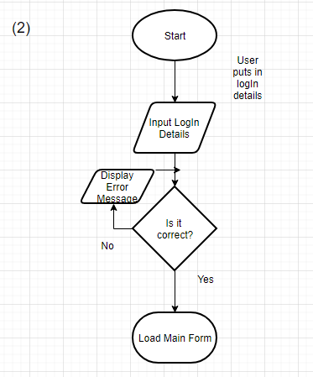

(3)

